1. 1007 X 993 = ______
2. 2 3/5 -11/4 = _________
3. Last week I travelled from London to Leeds, which is a distance of 174 miles. I started at 9.15am and completed the journey with an average speed of 40 miles per hour. On the way back, in the evening, I travelled exactly the same route, starting at 5.15pm. The traffic was light and I completed the journey with an average speed of 60 miles per hour. What was the overall average speed for round trip?
4. When it is 2.45 an upside-down clock’s minute hand points to the left. TRUE or FALSE.
5. 85% of 200 is the same as 34 multiplied by 5. TRUE or FALSE.
6. 369, 468, 567The next number in the above sequence is?
7. S762AC34BK5DNWrite down all the odd numbers from the above list in ascending order, followed by all the letters in reverse alphabetical order, followed by all the even numbers in descending order.
8. 629473168274923Add together all the odd numbers in the above list that are immediately followed by an even number.
9. What is “?”

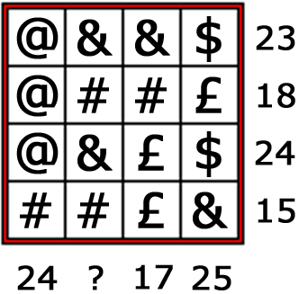

1. What letter in the English alphabet comes four letters before the letter that comes two letters after the letter N?
2. A car travels at a speed of 64Kmph and its fuel consumption is 28 Kmpl. It has a 11 Liters tank which was full when it started but at that very moment began to leak fuel. After 112 Km the car stops with a completely empty tank. How many Liters per hour was it losing?
3. What should replace the question mark? 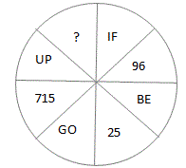
4. What should replace the question marks?

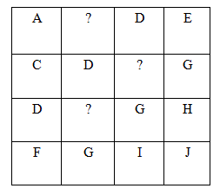

1. 364928, 109463, 94901, ?
2. An ant has six legs, a spider has eight legs and a mouse has four legs. In my zoo, I recently counted 612 legs which came from an equal number of each of these animals. Can you identify how many animals there are in my zoo?
3. An electrical circuit wiring a set of four lights depends on a system of switches, A, B, C and D. Each switch when working has the following effect on the lights:

Switch A turns lights 1 and 2 on/off or off/on.

Switch B turns lights 2 and 4 on/off or off/on.

Switch C turns lights 1 and 3 on/off or off/on.

Switch D turns lights 3 and 4 on/off or off/on.

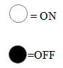

In the following diagram, switches C, B and D are thrown in turn, with the result that Set 1 is transformed into Set 2. One of the switches is not, therefore, working and has had no effect on the numbered lights. Identify which one of the switches is not working.

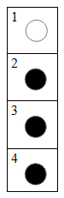 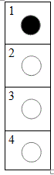

Set 1 Set 2

1. 7 6 5 3 1 9 7 2 5 6 3 8 2 1

Delete all the numbers that appear more than once in the above list and multiply the remaining numbers together. What is the total?

1. Capture6.GIF

Which symbol comes next?

Capture5.GIF

1. ●●□▬ ●●●□□▬ ●●●●□□□▬ ●●●●●□□□□▬ ●●●●

Which three symbols come next?

a. ●●●b. □▬●c. ●□▬d. ●●□e. ●□□

1. Daft Dave, our local DIY expert, is renovating the local hospital. He has to number each of the rooms in the hospital with plastic numbers. However, he has run out of the number 9. How many 9's must Dave buy in order to number all 1,000 rooms?

So much of the literature of the western world, including a large part of its greatest literature, was either written for actual speaking or in a mode of speech, that we are likely to deform it if we apply our comparatively recent norm of writing for silent reading. It is only that so much of this work is drama or oratory (the latter including the modern forms of sermons, lectures and addresses which as late as the nineteenth century play a most important part). It is also thought that through classical and mediaeval times, and in many cases beyond these, most reading was either aloud or silently articulated as if speaking: a habit we now recognise mainly in the slow. Most classical histories were indeed quite close to oratory and public speech, rather than silent reading of an artefact, was the central condition of linguistic composition. (For questions 21 to 24)

1. Until the nineteenth century, most people could only read with difficulty
2. TRUE
3. FALSE
4. CANNOT SAY
5. In ancient times, literature was intended to be read aloud
6. TRUE
7. FALSE
8. CANNOT SAY
9. Classical histories were passed on orally and never written down
10. TRUE
11. FALSE
12. CANNOT SAY
13. It is mainly people with literacy problems who now read aloud
14. TRUE
15. FALSE
16. CANNOT SAY
17. Debbie, Kimi and Michael have Ferraris.

Michael also has a Reliant Robin.

Jensen has a Mercedes and a Model T.

Rubens also has a Mercedes.

Debbie also has a Bugatti Veyron.

Rubens has just bought a Toyota Prius.

Who has the fewest cars?

1. Debbie
2. Kimi
3. Michael
4. Jensen
5. Rubens
6. What number comes next in this sequence:

12 13 15 17 111 113 117 119 123 ?

1. Jensen, Lewis and Mika need to be able to run 100m in under 12.5 seconds to qualify for a championship. Lewis and Mika run faster than Jensen. Jensen's best time for the 100m is 13.1 seconds.

Which of the following MUST be true?

1. Only Lewis Qualifies
2. Jensen doesn’t qualify
3. Lewis & Mika both qualify
4. Jensen Qualifies
5. No one Qualifies
6. Hanif, Horace, Hilary and Hannah are students. Hanif and Horace speak Chinese, whereas the others speak Arabic. Horace and Hannah speak Albanian. Everyone except Hanif speaks Esperanto.

Who only speaks Arabic and Esperanto?

1. Hanif
2. Horace
3. Hillary
4. Hannah
5. 5 bricklayers can lay a total of 50 bricks in 30 minutes.

How many bricklayers will be required to lay a total of 60 bricks in 18 minutes? ______

1. The month of March in the year 1980 contained 5 Saturdays and 5 Mondays. What day of the week was the 15th of March?
2. Using eight eights and addition only, can you make 1000?
3. An old treasure map has the following instructions:

Stand next to the black rock and face West.

Walk 20 yards and then turn 90 degrees clockwise.

Walk another 10 yards and then turn 45 degrees anticlockwise.

Walk another 15 yards, reverse your direction and walk 5 yards back.

Turn 135 degrees clockwise and walk another 10 yards.

In which direction are you now facing?

1. East
2. West
3. South East
4. North
5. South
6. Mrs Krashem, a driving instructor, has to arrange bookings for some of her pupils. She has 8 new pupils who wish to book either a morning or afternoon of a particular day. These are 2 hour introductory lessons, so she only sees one pupil each morning or afternoon.

Ms Banger is only available Tuesday AM but Mr Bumpem can make any time on a Wednesday.

Mrs Exhaust is free on Tuesdays all day but Mr Hilstart is only free Wednesday afternoons.

Ms Boot is only available Friday AM whereas Miss Bonnet can only make Saturday PM.

Mrs Speed is available all day Fridays whereas Mr Parker can make any time on a Saturday

Which of the following must both have MORNING appointments?

1. Mr.Bumpem & Mrs. Exhaust
2. Mrs.Exhaust & Mr. Parker
3. Mr. Parker & Mrs. Speed
4. Mrs.Speed & Mrs. Exhaust
5. Mr. Bumpem & Mr. Parker
6. How many degrees are there between the two hands of a clock at 6.30 am? ______
7. You have 6 brown socks and 6 pink socks in your drawer, all mixed up and identical in all but color. There has been a power failure. It is still pitch dark outside and you have no other light available.

How many socks must you take from the drawer to be sure of taking a matching pair of the same color?

1. 2
2. 3
3. 4
4. 5
5. 8
6. A crofter has to get to his herd of sheep quickly as he has been told they are being attacked by a dog. His sheep are on the other side of a steep hill. He can run over the hill (3 miles) at 4 miles an hour, or take his tractor via an old dirt track which is 5 miles at an average of 6 miles an hour or he can drive his car along a very narrow winding road but this is 14 miles and he can only go at 18 miles an hour on average.

Which method should he choose?

1. Tractor
2. Car
3. Running
4. The map below shows the street locations of a city. Position three police officers such that the entire length of every street can be seen by at least one officer.

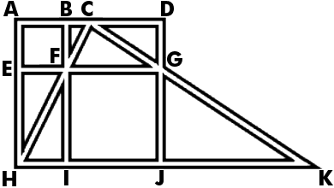

1. 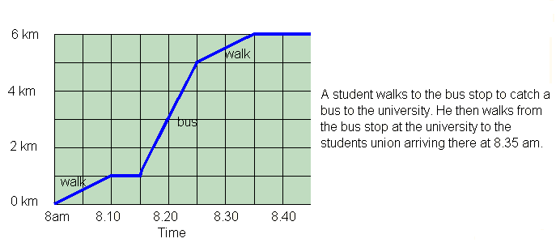
2. How far does the student walk in total? ____
3. How far is he from the university students' union at 8.20 am? ______
4. What is the average speed of the bus?
5. Which is the largest fraction:

a) 3/4 b) 7/8 c) 4/5 d) 7/9 e) 7/10

1. **Statements:** No door is dog. All the dogs are cats.

**Conclusions:**

1. No door is cat.
2. No cat is door.
3. Some cats are dogs.
4. All the cats are dogs

|  |  |
| --- | --- |
| [A.](javascript:%20void%200;) | Only (2) and (4) |
| [B.](javascript:%20void%200;) | Only (1) and (3) |
| [C.](javascript:%20void%200;) | Only (3) and (4) |
| [D.](javascript:%20void%200;) | Only (3) |
| [E.](javascript:%20void%200;) | All the four |

1. What is the next figure in the sequence below?

a.A b.B c.C d.D e.E

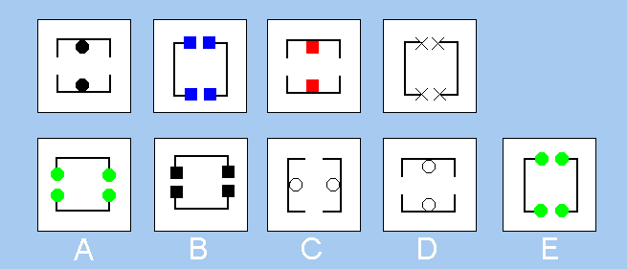

1. What is the next figure in the sequence below?

a.A b.B c.C d.D e.E

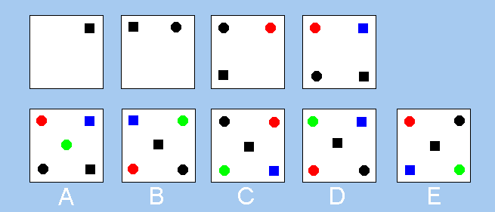

1. 1052-952= _____
2. ­­­Which of the following figures on the right completes the figure on the left?

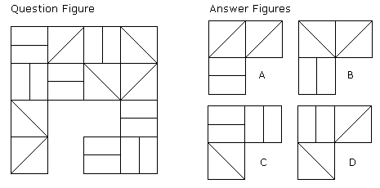

1. Which figure is identical to the first?

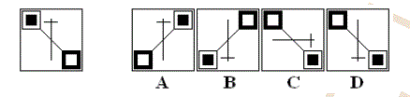

1. Which pattern can be folded to make the cube shown?

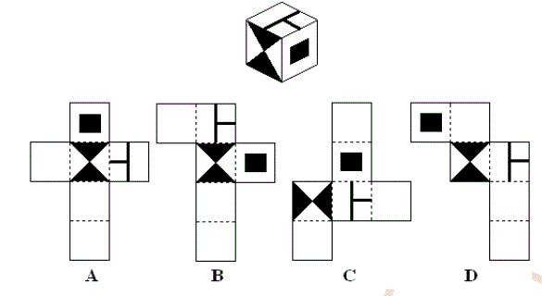

1. Which figure completes the statement?

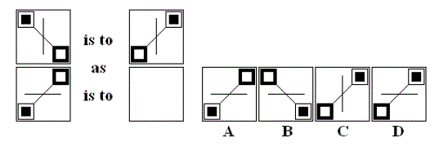

1. What is ‘X’ percent of ‘Y’ divided by ‘Y’ percent of ‘X’?
2. X
3. Y
4. 1
5. 10
6. 100
7. A man was engaged on a job for 30 days on the condition that he would get a wage of Rs.10, for the day he works, but he has to pay a fine of Rs.2 for each day he is absent. If he gets Rs.216 at the end, he was absent for _______ days?
8. What is the next number in the sequence?

2, 6, 12, 20, 30, ?